***K2T MACHINE MOVING CC***

[K2tmachine@gmail.com](mailto:K2tmachine@gmail.com)

Contact: Vincent Moodley

Cell No: 082 8788 567

Contact: Trevolin Moodley

Cell No: 083 996 1341

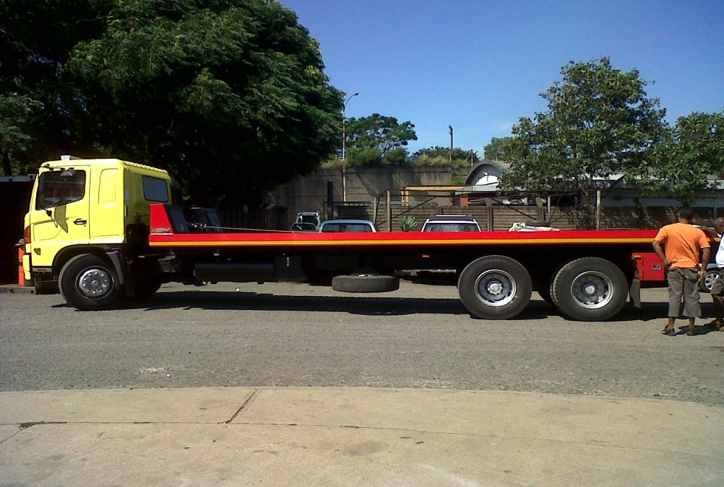

**WE SPECIALIZE IN MACHINE MOVING**

***K2T MACHINE MOVING CC***

**FULFILLING CUSTOMER NEEDS**

* Our policy is to remain competitive at all levels.
* Should you be in possession of a more competitive proposal, we will gladly review our proposal accordingly.
* We have the following vehicles for hire:
* Rollbacks –Max Load 7 Ton

Max Load 11 Ton

* Crane Hire-10 Ton at 6 Meter Deck
* Low-bed- Max Load 28 Ton

We specialize in transporting of Forklift; Bobcats; Tractors; TLB’S; Rollers & other Heavy Machinery

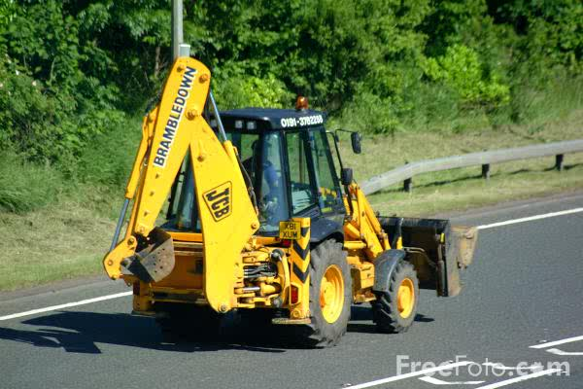

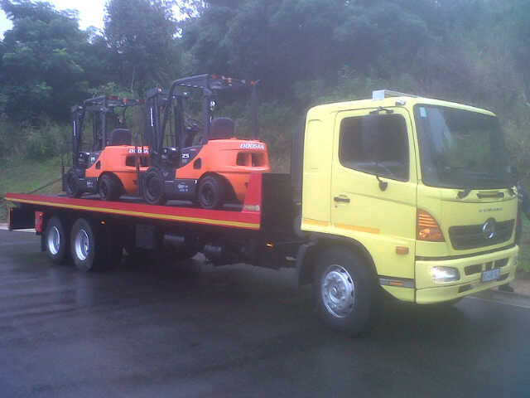

***K2T MACHINE MOVING CC***

**Pricing**

* Low Bed cost on request due to variations of the Equipment being moved
* Crane Hire Cost on request due to variations of the Equipment being moved

and Rates are available on request.

* Please see e attached Rates for movement of equipment in KZN.

***7 TON ROLLBACK TRUCK***

* 25 KM Radius = R 750.OO
* Thereafter R 9.00 per KM applies

***11 TON ROLLBACK TRUCK***

* 25 KM Radius = R 1,500.00
* Thereafter R 13.00 per KM applies

**Please note:**

AFTER HOURS EXCLUDES THESE PRICES

***WE OFFER A 24HR SERVICE***

***Reload prices are @ 50% of the Above Quotes